West Hull Ladies
RRC

June Newsletter
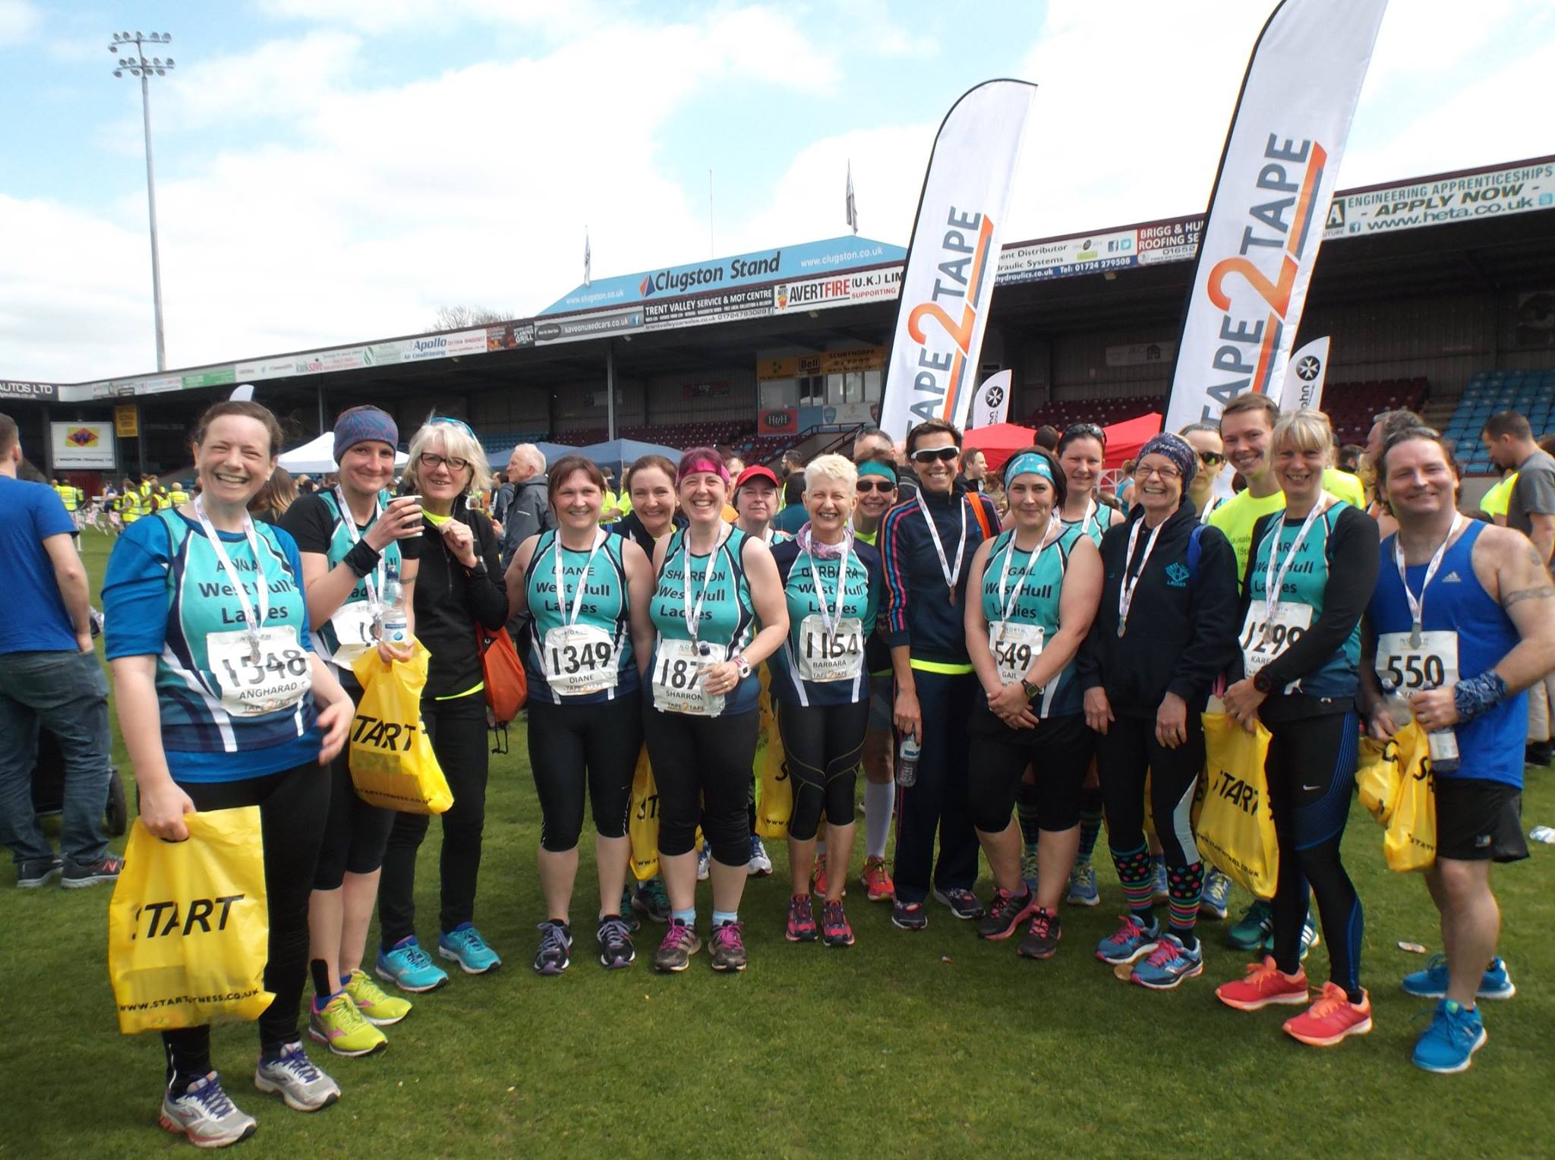

North Lincs Half Marathon
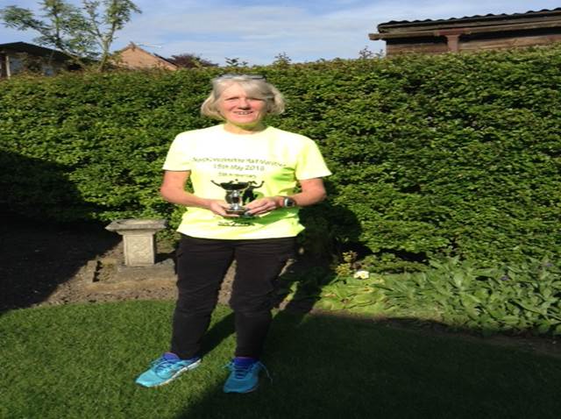

Sandra takes 3rd in her age category

West Hull Ladies
Committee Meeting Minutes
West Hull Ladies

Committee Meeting: Monday 6th June 2016
Present - Jill, Sandra, Jan, Anna, Linda, Ros

1. Apologies received from Amanda, Karen, Liz, Zoe, Annette
2. Minutes from previous meeting agreed as accurate record
3. Matters arising
a) Shell had been successful in getting 10 volunteers to marshal at the Hull 10k.
b) Amanda had sent out email to gauge interest in WHL hosting a race in 2017
c) Sandra still continuing enquiries with KCom re stadium reps training.
d) Amanda had circulated details of GB Relay
e) Amanda to update re possible LiRF at next meeting
f) Amanda still in process of arranging ‘Are you tired of being tired”
g) Updates not available re membership forms outstanding and Ben Smith running 401 marathons.
4. The possibility of WHL hosting a race for 2017 was discussed at length. Action Jill to contact Phil Lambert City of Hull to ask if he could attend a planned meeting and give advice on the feasibility of us as a Club being able to do this successfully.
5. A discussion then took place about Wednesday night training taking place from the Club. Responses to an earlier email about this had been sent to the Committee - these raised some good ideas around a steadier Wednesday group and having a steadier running group co-ordinator. It was then agreed that we would have a fortnightly buddy who would attend the Club. Action - Jill to email Committee Members on how this system would work.
6. Copyright had been raised as an issue in relation to non-purchased official race photos and other published items we used in newsletters. It was agreed that as long as we acknowledged where the articles had come from and we made no profit then we were happy to continue to do so in relation to all articles other then photos were copyright applied.
7. We had been forwarded details of a scheme where if we ran a beginners course in the summer months we could have a member trained for free as a LiRF. It was agreed that we did not have enough time to do this and it would be difficult with family and other commitments at that time of year.
8. Jill informed the group that Shell and Maria were attending a meeting hosted by Rich Harrison from Kingston upon Hull Running Club. They were there to obtain details of a cross-country league that he was interested in starting in the local area. To be discussed at the next meeting when more details were know.

Meet a Member : Shelley Hindley
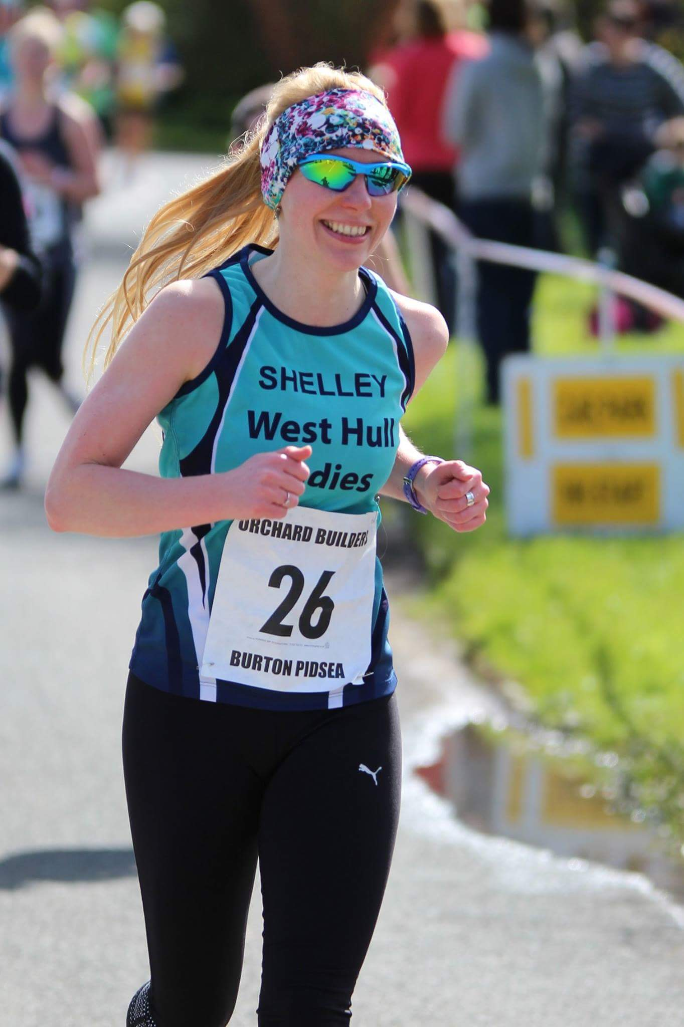
Age 35
Member of WHL since – September 2015
What do you do when you’re not running? – ( work/hobbies/family) I work at the University of Hull and run the MFL PGCE programme, where I train languages graduates to become qualified secondary school teachers (I was an MFL teacher before that for 10 years), it’s the best job in the world. Outside of work I do a lot of yoga, bodypump and spinning, I like to mix it up. I’m partial to a nice real ale (or three) on a weekend too.
How long have you been running? – Until I was 32 I hadn’t ran since school. I was quite good at it when I was younger but I wasn’t in the sporty set and didn’t carry it on at 6th form. However, I did my first parkrun in June 2013 and have kept going from there. I beat the girls from the school sporty set during races now.
Why did you start running? – Basically, I saw some friends running and doing well and I thought I’d try it. I never planned to be a ‘runner’, but once you start with a parkrun it’s a slippery slope. You meet other runners who are ‘run-pushers’, they say “just try a little 10k, it won’t hurt”, you spend more money on socks in Humber Runner than you do on pretty dresses in Topshop, your body craves the endorphins, so you do harder, longer runs to get a ‘hit’. Finally, when you’re sweaty and shaking you realise what has happened to you, you join a group of people with the same issues and say “Hello, my name is Shelley and I’m a runner”, and they say “Great, shall we do Cott Alleys?”.
Favourite distance – 10k at the moment, I’m hoping that I like half marathons but will see at Humber Half!
Favourite bit of running kit- Has to be my Buff headbands, I hate getting earache from the wind and you can get some very snazzy ones from the website.
Any injuries? – Niggles! I get told off for saying injuries. I had a bad fall on my snowboard in Andorra about 6 years ago (there is a story behind this that I can laugh about now, I’ll tell you it if you have a spare 10 mins), which left me with left glute problems, which then pulled the SI joint in my hip out of place and also makes my knee hurt, but it’s getting sorted out now with strengthening exercises. I’ve had mega shin splints too, everyone has heard about my shins, and again they just needed sorting with strengthening exercises.
Running goals? – To get faster and to still be running with a smile when I’m an old lady and everyone else my age uses a mobility scooter. I don’t know if I dare say a marathon, I’ll see how Humber Half goes first.
Proudest moment running related or otherwise – I have lots of proud moments, in my line of work I help people to be successful and have to get them through some tough times, so when they come through shining it makes me so proud. My proudest running moments are yet to come …
Best piece of advice you’ve received – I’m sure you have all heard this one but … ‘If you think you can or you think you can’t, you’re right’ – it applies to everything in life, having a growth mind-set means there are no limits.
Running alone or with friends? - Always with friends.
What keeps you motivated? – My grandparents, they were always my cheerleaders when they were alive. I lost my grandma to Alzheimer’s in January this year and she would be livid if I didn’t try and make my life as fun and glorious as possible.

Meet a Member : Ann Holmes

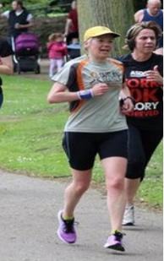
Age 47
Member of WHL since – 2011
What do you do when you’re not running? – (work/hobbies/family) – I have an allotment and a greenhouse, so am enjoying attempting to grow plants that can be eaten by us instead of the slugs and pigeons.
How long have you been running? – six years
Why did you start running? – A surgeon fixed my knee so I could run without pain for the first time in years.
Favourite distance – Marathon – I like a race to be a day out. Its also the best reason for pizza and ice cream sundae.
Favourite bit of running kit – My pirate running cap (see photo), in fact its called a ‘head sweat’ – keeps the sweat / rain off and covers any bad hair day.
Any injuries? – Looong story! I’ve had three ops on a cruciate ligament injury on my knee, and it practically left me grounded last year. Luckily I tried a different rehab guy last October, and with a big commitment to an intensive rehab programme, it looks like I’m back, and pain free!
Running goals? – Comrades Ultra marathon in South Africa, and maybe, just maybe, membership of the 100 Marathon Club
Proudest moment running related or otherwise – finishing the London to Brighton 100k, two years ago. What a toughy that was, leg pain meant I had to walk the last 20 miles but my son walked the last 5k with me, at 2 o’clock inthe morning!
Best piece of advice you’ve received – Kris Lecher’s rehab guidance. He’s a City of Hull runner who wins races and a rehabilitation therapist. I’ve been following his advice for months now, religiously, and its worked!
Running alone or with friends? – both. Its good to catch up with friends, and it helps me run a bit faster, but I love the solitude of running on my own. I also like running with strangers, and have often coupled up with someone at marathons, for hours sometimes. I met someone just after the start of East Hull 20 one year, we ran together until mile 19, and we’ve been friends ever since!
What keeps you motivated? – Sheer joy. Running makes me smile and enjoy my food more. I can’t imagine ever not wanting to run.

Conti Run : Jill J
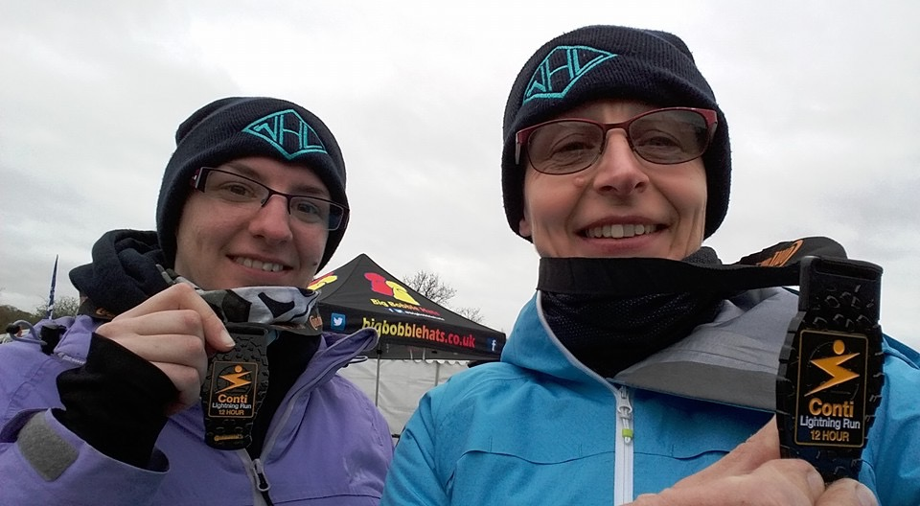
Last year, me and daughter Zoe thought it would be a good laugh to go to Catton Park in Derbyshire (the home of the dreaded thunder run, but a different course) to have a go at the 12 hour Conti run. To be honest if the weather had been as it was on the weekend of the Beverley 10k, it would have been lovely, however this was not to be.
We arrived on the Saturday afternoon just at the point when the heavens decided to open, so sat in the car until it eased off, before putting the tent up. We were quite optimistic at this point as we had a great tent pitch near the start and the weather cleared up enough for us to have a barbecue. However as the night drew in, the temperature plummeted! I have to say that I nearly went and joined Zoe and her boyfriend Tom in their sleeping bag, it was so cold! I had about an inch of face out of my sleeping bag and I'm sure I had icicles on my nose! I didn't sleep at all, and was pretty fed up when the alarm went off at 4am, for a 6am start.
I decided to try and make breakfast whilst still in my sleeping bag and was desperate for a hot cup of tea, so I shuffled across the tent like a demented caterpillar and stuck my head out of the tent to try and boil the kettle on the stove which was outside. It was so cold that there was ice on the tent, and the pathetic gas ring struggled to heat the water. The luke warm cup of tea that I made, was very welcome however, and I then decided to try the toasting rack. This was a major mistake as the gas stove must have been slightly leaking some gas and promptly ignited! This was very scary as it was near to the tent side, so without thinking I picked it up and threw it away. I was then worried that the gas bottle would explode, but fortunately because it was so cold it all went out. This was a bit of a wake up call in more ways than one, and will make me buy a fire extinguisher for our next adventures!
Anyway 6am came and the race started. I did the first lap, which was quite muddy in places, and having fallen down at the triathlon the week before, and also at the champagne league, I was being very careful! Zoe then took over and was quite a lot faster than me, which was pretty good as although neither of us had trained for this, she had hardly been doing any running at all lately.
You might be thinking that we are actually totally crackers even attempting a 12 hour run without proper training, and I would agree with you here, but we had already decided that we would use this as training for endure and tr24, and also that we would be honest with each other when we wanted to stop. I had already decided that I wanted to do four laps, which would be just under 25 miles, so that's what we both did. I have to say that I did find it quite tough, and the next day I felt really rough and thought that I was going to be sick in my car on the way home. This was either a bug from the toilets that were disgusting by the Monday morning, or that I had not got my nutrition and hydration right. I have to say that having spent most of bank holiday Monday with my head down the toilet feeling dreadful, I was at that point of: 1. Never going camping ever again; 2. Giving my Endure and Tr24 places to someone else; 3. Never running any long races ever again; and 4. By the end of the day never running again!! Anyway, fortunately I felt better by the next day, and by mid day had entered the London marathon ballot!!
Even thought this Conti run sounds a bit horrid in my write up, it actually is quite a nice course, and the event is really good. It's much more low key than TR24, and would be probably quite a good trip for less experienced ladies who fancied doing a team event, as you can do it in a team of 5. You could even pitch the events tent on the Saturday and go and stay in the nearby travel lodge on the Saturday night!!
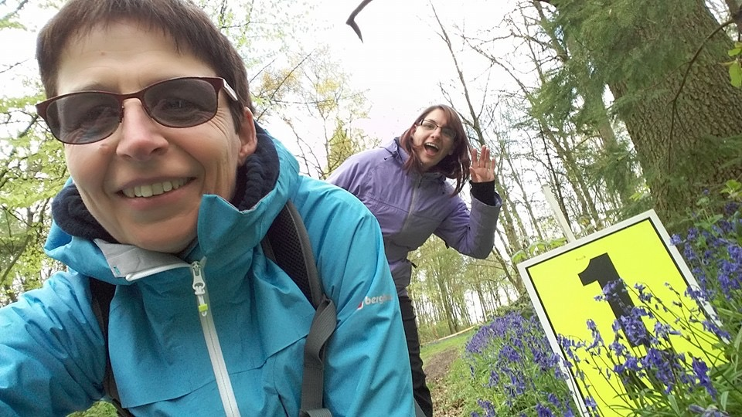

Beverley Ten K: Sharron

Wow – what a scorcher of a day and what a WHL turnout!!!
I missed the official photo shoot along with a few other WHL so when I saw Karen in the middle of an unofficial photo shoot I ran towards her and up the mound shouting “wait for me, wait for me…….” And I photobombed! That little stretch of the legs along with the wander to the start must have warmed me up even more as I was really pleased with what I achieved today.
With my mantra of “don’t start too fast, don’t start too fast” going through my head, I set off with everyone else and I actually DIDN’T start too fast, I just can’t believe it, as going off LIKE A ROCKET then FADING DRAMATICALLY AT THE END is my thing!!! In truth, I PROBABLY went off a LITTLE faster than I should………..but nothing to what I normally do!
Anyway, setting off I found that I hit a rhythm sooner than I usually do (the SLIGHTLY steadier start…….???) I managed the first long incline without stopping, which spurred me on a little. I found that I was overtaking a few runners, I don’t normally do THAT!
I had taken a water bottle with me, so it was my choice or not to stop at water stations. If it had been overcast I would have run straight by BUT, with the weather being what it was…….hmmmm better take on as much water as I could. Coming into the first water station there was a queue at the table “Oh noooo” I thought, so I chose to run on, then I KNEW I was going to have a good day as, just a little further on, there was a lone person handing out cups of water! “Hurrah” water AND no queue!!
I remember seeing Sandra……yippeeeee…….that got me going again.
So, I carried on. My little legs were working very hard but everything felt ok. I steadied myself for the next incline, got my head around it, gave myself a stern talking to and just motored up it (ok - motored MAY be the wrong word) but I got up that in one go too ☺. Even though I started chuntering away to myself at this point and had my usual moan of “whhhhyyyyyy……………..do...I...do…this????” And, even though my legs were screaming at me……..maybe, just maybe, this is going to turn out to be a good run(?) daren’t think about that just yet, it is ME after all…….. Then, just before the 2nd water station Karen Scott come alongside me, so we ran together for a little while, which was nice. Although I couldn’t speak to her AT ALL as I was concentrating so much on keeping my rhythm going and on my breathing. I found that I opened my mouth, and………………(silence)………….. Now, people who know me KNOW I like a little chat (ahem) so even I scared myself half to death when nothing came out!!! Anyway, we decided to get some water and then I was able to stutter to her “you go on, I’m doing ok” (and I really was…..). We carried on for a little while together after leaving the water station and then Karen pulled ahead of me.
I DO like the run in from the second water table. I feel that I find my rhythm, there are always a fair few people cheering you in, which is ALWAYS a boost and today, it was about that time that I just found myself falling into step with random people (got to confess - it was mainly random men......) ……….and they were probably sneaking a look at me thinking “what’s this one doing??? Why is she running with me???” But, it worked for me………whether they were trying to shake me off or not, I blooming well ran with them!!
Then, strangely enough, I started overtaking these random people (WHAT’S ALL THAT ABOUT!!??!! I really aren’t used to overtaking people). I’d run alongside one then, when whatever it was (that’s how unused to do it I was) felt right I’d run alongside another, then another. Doing that got me to half a mile or so to go, whereupon I saw Karen and Sarah JW ahead of me. So, I locked my eyes on them and just ran. I could feel myself getting slightly closer, I could hear all the people clapping and cheering and calling my name. Still, I didn’t take my eyes off Karen and Sarah. All of a sudden, due to the fact I was concentrating so hard on them the finish came upon me, right, last push, head down, lets pelt for it……….and I did!!
As I finished the race and caught up to Karen and Sarah, to thank them for bringing me home (though they wouldn't have realised they did) I saw the effort Sarah had put in to this race, but when I was happy she was ok, then I felt MY whole being scream at me……….WATER…………YOU NEED WATER…………….
Whilst drinking the much needed water we all waited for the rest of the WHL to come through the finishing line. Well done everyone, it WAS a hard one this year.
I’ve got to say even though it was a very hot day, I still got myself over a 5 minute Beverley 10k PB ☺ How on earth did THAT happen…………so pleased………..
Ooooooo, I KNEW this was going to be a good run…………… ☺

North Lincs Half Marathon : Sharron

Well…..last time I entered this was 2014. I wasn’t well, I hadn’t put in the training I should have, I hated every single painful step of it, this was a race I was determined to conquer and bring to an end all the bad memories I had of it. It IS a well organised, very well supported race after all….
So, this time round, training plan sourced, I looked forward to when my 12 week training plan would start…..then disaster…..I started feeling a little poorly again. WHAT IS IT WITH THIS RACE???????
Therefore, my 12 week training plan turned into a (let’s hope it works out) 8 week training plan…….but, I put as much training in as I could, thought I’d caught up well and now it all depended about what happened on the day……
Anyway, we set off on our journey there; Anna, Nige (Hubby) and me. Us ladies as nervous as anything, keeping our eyes on the skies as we were promised overcast but what we saw wasn’t cloud but sun……Uh-oh
Now Karen Scott, a little while back mentioned that she would pace me round. In a moment of sheer madness I thought “Woah, let’s try to get round in 2 and a half hours” THEN in ANOTHER moment of madness; “Woah, let’s go for 11 minute miles; 2 hours 24 mins…..” (Cue hysterical laughter from somewhere inside my head!) So, it was 11 min miles I suggested! When I was stood all nervous at the start I began to doubt my ability for 11 minute miles. Then, Horror of Horrors!!!……..I saw the mile pacers…..Karen was hoping I HADN’T noticed the mile pacers…….ha, I saw the mile pacers alright as I was stood IN THE MIDDLE of them…….slap bang in the middle of the 11.27 pacers and the 10.18 minute pacers!!!!…..Arhhhhh…what do I do??? Where do I go???? 10 minute pacer nearby???? Stress! Stress!! Stress!!! Arhhhhh!!!! J
As it was, we started out really well. We ran just behind one of the 10.18 pacers. Surprisingly I felt comfy there with him. I wasn’t prepared to overtake him, no way! I was imagining that a centimetre in front of him would turn my legs to jelly and I would just wobble over to the grass and collapse! What was lovely was that every now and again, both the 10.18 pacers would shout “ALL IN!!!” they’d hold their phones up aloft and we would then all pile in for a ‘North Lincs Half On The Move’ selfie…..how good is THAT!!???!!
Karen HAD mentioned beforehand that as it was a race we were NOT to chat……..I agreed to this, knowing that I wouldn’t in a million years stay quiet……sorry…….!! J

So, the first 10k went brilliantly, Karen said I’d hit another 10k PB a week on from last week’s new PB J We were running well, going at a very manageable and steady pace, we were chatting well, we were photobombing the pacers well…..everything was good. It was warm, we took on water when we needed to. I don’t have the ability to run and drink so Karen suggested limiting ourselves to a 30 second walk to drink then get back to running, so that’s what we did, although we only did that at 3 water stations. We were so excited when we found out there was a sponge station coming up…………A WET SPONGE STATION; a first for me, how fab is that!!!!
6.5 to 7 miles, I ALWAYS have a little meltdown, can’t help it, don’t know what it is. I did quieten down a little and I noticed Karen kept looking over to check I was still with her, so to speak, and I was, just about.
7 to 9 miles, went ok too. I was still moving though I started feeling that I needed to dig in a little more at around 8 miles. So I quietened down a little more.
9 to 11 miles, beginning to feel it in the legs, the long, long lane we were running down didn’t help, very long, seemed never-ending but, I was still going.
11 miles, my head had a little wobble, my usual thought of "Gawwwwd......Why.....am....I....doing....this....!!!???!!!" The top of my right leg was beginning to ‘sing’ a little at me. When we approached a water station I took this opportunity to stretch. ‘Come on leg’, all that training I’d done, I wanted to finish, don’t let me down now!!
11 to 12.5 miles, I quite like the run on the road in before the incline. I remember this stretch from last time and I didn’t mind it then either. As we were running all the cars passing us were honking their horns, keeping us going, I really liked that. Karen and I steadied ourselves for the nasty steep flyover near the end. Whether I was desperate to finish I don’t know, but I kept speeding up. Karen, rightly so, kept slowing me down. As, when I eventually got there, I didn’t want to get halfway up this incline, stop and roll backwards!!!
Approaching the incline Karen prepared us for it. “We are not going to stop Sharron, we are running up and over it”, “ok” I panted, “Get yourself ready for it, get your breathing right”, “ok” I panted, “Here we go, you ready”, “ok” I panted, “Don’t let people who are walking put you off”, “ok” I panted. (How IS she DOING THAT??? How IS she still able to TALK??!!!??) So, we were on it. Head down….come on legs, you can do this. People WERE walking, we overtook some, overtook some more, woah, I’m actually running UP this thing!!! Getting to the top I began to get my breathing ready for the (painful) run down. Again people were walking, which unfortunately split Karen and I up. It seemed like some romantic movie at this point as Karen moved ahead, looked back at me, arm outstretched, shouting “Sharrrrrrrron……..” I became caught behind those walking, I looked forward to her, arm outstretched, shouting “Karrrrrrrrren”………

Arm outstretched still; ”Sharrrrrrrron”

She was within reach, arm outstretched, “Karrrrrrrrren”

I caught up to her…..”Oh Karrrrrren, I thought I’d lost you…….”

As we turned the sharp right turn after the flyover, I started getting emotional. Karen said “Don’t get emotional – not yet, try to save it for the ground”, “Ok” I sobbed!

200 metres to go, I heard those immortal words from Karen again…..”Sharron, you’re really going to hate me now”, I’m a quick learner, I have learnt that that phrase roughly translates into words such as ‘SPEED’ and ‘SPRINT’ and ‘GIVE IT YOUR ALL’ and ‘FAST’

I really did try to speed up, who knows if I did. Karen grabbed my hand and said, “we started together, we are finishing together” oh no, I was getting emotional again.
And, we DID finish together, how lovely. We were cheered in………..uh-oh, here come the waterworks………..
We hugged each other so much after finishing, it was lovely. We found the other WHL who had already finished, we cheered in those now finishing, how lovely. Saw our Sandra win a prize, how lovely.

What a day!!! So proud of EVERYONE.
A special mention to Anna, as this was her first half marathon, well done Anna! And to Karen for getting me round in one piece, thanks Karen!
Just one more thing to add………..Never in my WILDEST DREAMS did I think I would run this in 2 hours 15 minutes. As I said, last time I did this I wasn’t very well so maybe it’s not as much as a big deal BECAUSE of that…..but…..I ran this one over 37 minutes quicker…………… J

Sharron

North Lincs Half Marathon : Anna

Well- this was my new year's resolution (or revolution as my brother used to call them!) For some time I had felt that I should be pushing myself a bit more, and was frustrated that I had never broken into the distance of a half. No one ever pressured me, but I felt that I really should give it a go.
So- on new years day, I found that there was a place free in this race that I knew was popular with the club, and pressed “ pay now”. Easy bit done.
Sharron and I devised a simple training plan- she really did hold my hand through it! She came up with all sorts of routes that were designed to help psychologically- familiar routes, with manageable sections, and she would always try to incorporate a loo stop just in case! I did seem to miss several due to a more active than normal social life! It would appear that Sunday mornings are not the best morning for me to plan long runs! But the best plans are adaptable, and I met with Jane for some distance too- who also, as ever, gave me lots of confidence.
The day finally arrived and I was so relieved. I have to apologise to those from the club that had to listen to my usual pre- race moaning: ”too many layers” “too few layers”, “another wee” Argh! I am never settled before a race- I just wanted to get started.
After the walk to the start we did indeed start, and it felt great to be off. I lost everyone straight away- which I hadn’t imagined, but the start was quite busy, and its hard to get round people as everyone finds their pace.
At mile one Gail's husband came past me with some encouraging words, followed by Gail. We ran the next 3 or 4 miles together- finding a lovely pace that suited us both. This first part of the race I don’t think I thought about the running at all- we were just busy nattering. It really did seem to go quickly.
We caught up with Liz in time for the second water station. This was to form the pattern of the race. I played catch up with Liz the whole way. At a water station she would zoom off ahead, and I would spend the next two miles gradually catching up.
I stopped properly at every station, bar the first, having still not mastered drinking and running. It worked well for me. It was only a half minute/ minute stop, but I had a proper drink and felt rested enough for the next stretch. By the last two stations it also gave me chance to stretch my knee out, which had held up really well, but just needed a pull.
At mile 7- 8 I started to feel it- my legs turned to lead, and the route seemed quieter with less to distract me. But that soon passed, and I settled into a rhythm again and plodded along.
Until mile 12 that is! It was awful. I really could not be bothered by this point. I was bored of it, and the scenery was no longer pretty. I was irritated by the camber in the road which was steep and irritated my knee, and I couldn’t see the end- which by this point I was sure was near.
What I could see was a familiar red hat bobbing along in front- it was Liz again- so I gave it all I had, which was not much by this point, and went to catch up with her. I overtook the 2 and a half hour pacers, who were in great spirits and shouted “run west Hull run”! As I staggered past them, barely faster than a brisk walk, I mustered a rave style arms in the air and a strained smile, but had no more energy than that!
I got to Liz, and thank goodness that I did. She really did get me through that last half mile. Mostly by signing to me! It was so lovely.
The end- running into the stadium- was wonderful! I saw Lynns hand high in the crown waving- and then saw all the club- what a fabulous sight they were! We all buzzed about- high from the run, and watched Sandra get her prize- well done!
This had been a brilliant experience. The first time I did a longer distance was Snake lane ten miler, and that had bothered me, as I had found it so hard. It had been a real challenge, which threw my confidence a bit. So, to complete this half feeling really comfortable and enjoying it was a relief.
I was also delighted with my time. I just decided to go for turning up, running, and completing it. Any "good time" was a bonus. I had seen the time at half way- but thought that I was pushing it to make it to the end at the same pace. I had also run past those pacers, but I didn’t know if they had been before or after me starting- so that was no help either! So I was really pleased to get just under 2 and a half hours.
This race deserves its popular reputation from our club. There is so much support out on the course. At every crossroads or farm there were people out. This made such a difference. And the water stations were so well organinsed. And to top it off- vegi jelly beans – how thoughtful!
After Sharron had to pull me out of the car, I got home to a lovely Sunday dinner waiting, and spent the afternoon in the kitchen listening to this:
https://www.youtube.com/watch?v=L7CL8anA1hQ
Thank you Liz! I wonder if it could become a club anthem?!
Anna

World Championship Duathlon: Amanda D

Last September I found out the Worlds was in Spain this year and therefore within travel reach though I was unsure whether to go for it. My form was not as good as a year or so ago and I only wanted to go if I had a chance of a podium place. And there was the cost. Duathlon/Triathlon is so expensive! In the end I decided to go for the qualification and make a decision after. I intended to compete at standard distance which is run 10K, cycle 25 miles and run 5K. I was sure I could qualify but if I was to go, I had to be first qualifier at the qualification event. I trained and despite nerves, I qualified with a good time gap ahead of the next competitor.
Next hurdle was the expense. I came out with a begging bowl and eventually was successful. I am very grateful to all my sponsors: My department (ICTD Hull University), ASM Global, West Hull Ladies and my friend James. In addition the Sports Science department provided injury prevention massages and a Vo2Max test. Andy (Hull Thursday) lent me a TT cycle helmet. Mark (Hull Thursday) lent me a bike bag and Daren (Ellerkers bike shop) lent me a double wheel bag.
Thank you everyone
Lots can go wrong in a duathlon. The obvious: injury, illness, bike mechanical but in addition you can get penalties for all sorts of things! Drafting, dangerous cycling, littering, number belt in wrong position. Plus you can really mess up transitions and lose plenty if your bike handling skills are rough or you don’t position well to keep tucked down or if you run inefficiently. And the kit makes a big difference, bike, helmet, running shoes. Then getting nutrition and hydration right and, did I mention drafting! Stressful. If you go within 10 metres of someone you have to overtake them within 20 seconds. Having only competed three other duathlons (one was a sprint) my experience was lacking.
I tried treating it as a project and gained as much help as I could: advice from Mark McKeown sports scientist (nutrition, general training), Kris Lecher physio (running gait analysis, flexibility) and nagged the life out of James Bray (Sports Scientist and successful triathlete) for transition advice. I bought new cycle shoes which had a single Velcro strap and light running shoes. The training was difficult because although I had general advice, there was no set schedule. I did brick sessions (run/cycle in same training session), some run races and club time trials but I had no idea how much to do. I tried to be confident as the run races had always produced a first in my age category and I was getting some PBs on time trials.
And despite all that … I arrived in Spain feeling like a fish out of water. It’s so complicated with registration one day, bike inspection and racking another, race on the next day and all the other events: cycle recce, team meeting, team photo, opening ceremony and presentation ceremony. But, with the help of partner Neil I made it through all the scheduled tasks.
This is how it went:
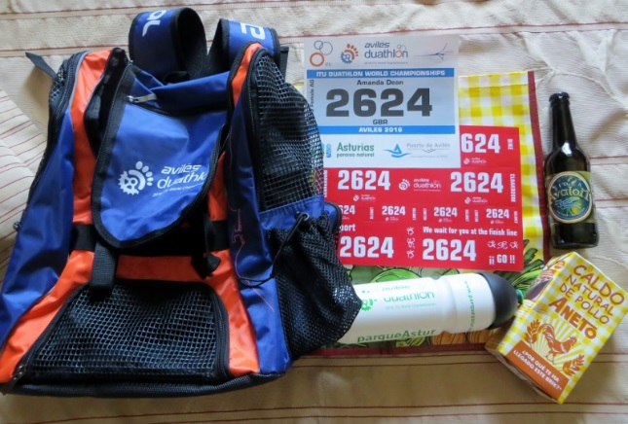
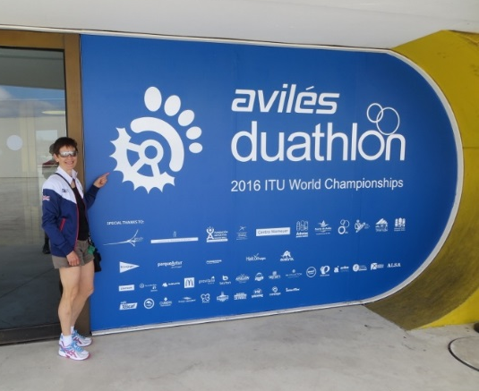
Day 1 (Thursday): Registration don’t forget your British Triathlete membership card
Multitude of numbers for me, bike & helmet. Goody bag including chicken soup!

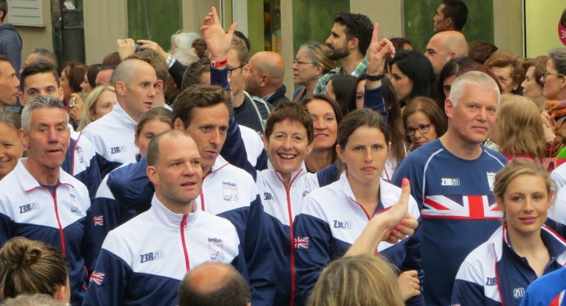
Day 2 (Friday): 10am cycle recce.
Evening opening ceremony. All nations walked through the town to the Plaza d’Espana. It was amazing being with all those athletes representing Great Britain.

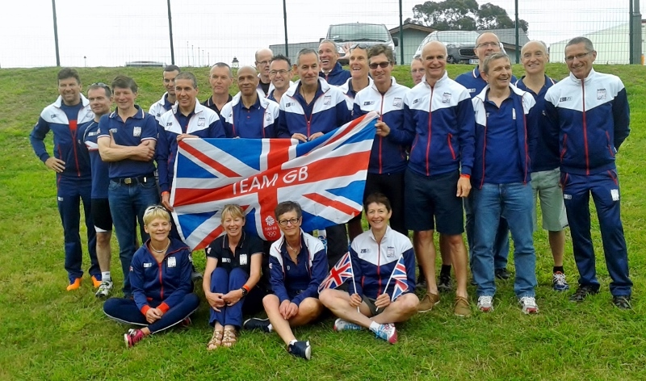
Day 3 (Saturday): team briefing and team photos.
Into town to rack my bike. It and your helmet and kit has to be checked. You don’t get your timing chip unless it is OK. I passed. Then you leave your bike which is really strange. I then watched some of the elites race. Emma Pallant, GB, took gold.
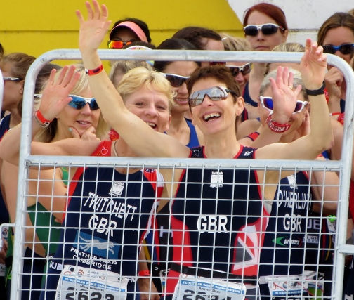
Race day: did not sleep well! But, it went almost as well as it could.
Pensive waiting for race start.
Neil spotted - a big cheer for the camera with GB National Champ Mary Twichett

Then we were off

The 10K was 47:06 which was slow but it was a long 10K (10.7K) so happy with that time .. and it was hot (25C)!
T1 was 28 seconds slower than the fastest transition time. If I ever did this again I have to learn to mount the bike with shoes attached to the pedals.

The cycle was long (25.8) miles. My time 78:22, not as fast as hoped but difficult to keep the rhythm with the numbers of cyclists on the road and having to judge when to pass. Towards the end my right calf was seizing up. I think I did not drink enough.
T2 was good, which is down to learning to dismount leaving shoes on the pedals. I was just 1 second short of the fastest time.
But … my final 5K (which was 5.5K) was terrible. My quads and right calf were tight to snapping. Quads eased out but my calf continued worryingly tight, it felt ready to tear so I had to stay steady plus I was knackered. I was really slow 27:37.
I was slightly disappointed missing out on the podium (I was 75secs off a podium place).
An Aussie took gold, then our GB National champ Mary (photo above), then USA lady, then me. But, once I thought about it, 4th is good for World championships so I am happy with 4th.
And I gave a competitive performance.
Could I do better? I think I possibly could
Final night was the presentation ceremony. It was awesome! I was relaxed, there was fabulous thrilling music, and GB had winners on almost all of the podiums. It seems we are good at duathlons.
Well it has certainly been an adventure. I’ve reeled between this is too complicated and stressful to this is amazing. It has not been easy getting there but so pleased I did. I am very proud to have represented Great Britain at the Duathlon World Championships 2016. It still sounds surreal saying that!

2016 RACE DIARY

Free 5K time trial every Saturday 9am:
Hull Parkrun Peter Pan Parkrun Humber Bridge parkrun

Double check dates, times and entry fees with the official website or the entry form. Zx Website contains all the links to the races: http://westhullladies.org.uk/races.htm
June 2016
 | 5th/TBC | Jane Tomlinson Burnley 10K | £21.54 UKA/£23.68 | Online entries only | Online entry
 | 10th/19:30 | Sledmere Sunset Trail 10K | £13 UKA/£15 | Online entries only | Online entry
 | 14th/19:15 | EHH Summer League Sproatley 7 Miles | £6 UKA/£8 | Enter on the day | Enter on the day
 | 19th/TBC | Jane Tomlinson Hull 10K | £24.68 UKA/£26.82 | Online entries only | Online entry
 | 26th/09:00 | Humber Bridge Half Marathon | £22 UKA/£24 | Online entries only | Online entry
 | 28th/19:15 | EHH Summer League Coniston 10K | £6 UKA/£8 | Enter on the day | Enter on the day
July 2016
 | 3rd / 10:45 | Withernsea 5 | £10 UKA/ £12 | Online or on the day | Online entry
 | 10th/10:00 | Caistor 10K | £11 UKA/£13 | Online entries only | Online entry
 | 10th/09:30 | Jane Tomlinson Leeds 10K | £25.82 UKA/£27.96 | Online entries only | Online entry
 | 12th/19:15 | EHH Summer League Skirlaugh 8 Miles | £6 UKA/£8 | Enter on the day | Enter on the day
 | 15th/19:30 | Walkington 10K | £11 UKA/£13 | Online entries only | Online entry
 | 17th/11:00 | Castle Howard Trail 10K | £13.70 UKA/£15.70 | Online entries only | Online entry
 | 17th/11:00 | Castle Howard Trail 6K | £11 UKA/£13 | Online entries only | Online entry
 | 17th/10:15 | Dalby Forest 10K | £23 | Online entries only | Online entry
 | 17th/10:45 | Dalby Forest Half Marathon | £24 | Online entries only | Online entry
 | 23th/TBC | Yorkshire Wolds Half Marathon | £13 UKA/£15 | Online entries only | Online entry
 | 24th/10:00 | Burton Constable Hall 10K Trail Race | £15 UKA/£18 | Online entries only | Online entry
 | 24th/09:30 | Great Yorkshire Run Harrogate 10K | £19 | Online entries only | Online entry
 | 26th/19:15 | EHH Summer League Hedon 4 Miles | £6 UKA/£8 | Enter on the day | Enter on the day
 | 31st/10:00 | Great Grimsby 10K | £10 UKA/£12 | Online entries only | Online entry
August 2016
 | 7th/09:30 | Jane Tomlinson York 10K | £25.82 UKA/£27.96 | Online entries only | Online entry
 | 21st/11:00 | Escrick 10K | £13 UKA/£15 | Entry form | Online entry (+£1.70)
September 2016
 | 4th/10:00 | Major Stone Half Marathon | £18.70 UKA/£20.70 | Online entries only | Online entry
 | 4th/11:00 | Tholthorpe 10K | £10 UKA/£12 | Entry form | Online entry (+£1.40)
 | 4th/10:15 | City of Salford 10K | £13 UKA/£15 | Online entries only | Online entry
 | 11th/09:30 | Vale of York Half Marathon | £21 UKA/£24 | Online entries only | Online entry
 | 11th/TBC | Great North Run | Race full | Race full | Race full
 | 11th/10:30 | The East Coast Classic 10K | £10 UKA/£12 | Online entries only | Online entry
 | 11th/11:00 | Shepley 10K | £10 UKA/£12 | Online entries only | Online entry
 | 18th/10:30 | The Tadcaster 10 Mile | £16 UKA/£18 | Online entries only | Online entry
 | 18th/09:00 | Hull Marathon | £40 UKA/£42 | Online entries only | Online entry
 | 25th/10:00 | Isle of Axholme Half Marathon | £20 UKA/£22 | Online entries only | Online entry
 | 25th/11:00 | Bishop Burton College Canter 7 Miles | £10 UKA/£12 | Online entries only | Online entry
 | 25th/09:30 | Ikano Robin Hood Marathon | £40 UKA/£45 | Online entries only | Online entry
 | 25th/09:30 | Ikano Robin Hood Half Marathon | £31.75 UKA/£36.75 | Online entries only | Online entry
October 2016
 | 1st/16:00 | Bournemouth Supersonic 10K | £24.50 UKA/£26.50 | Online entries only | Online entry (+£2.08)
 | 2nd/08:00 | Bournemouth Half Marathon | £30.50 UKA/£32.50 | Online entries only | Online entry (+£2.08)
 | 2nd/10:00 | Bournemouth Marathon | £50.50 UKA/£52.50 | Online entries only | Online entry (+£2.08)
 | 15th/11:00 | Gruesome Twosome Half Marathon | £20 UKA/£23 | Entry form | Postal entries only
 | 15th/10:30 | Gruesome Twosome 10K | £13 UKA/£16 | Entry form | Postal entries only
 | 16th/10:00 | Bridlington Half Marathon | £15.50 UKA/£17.50 | Entry form | Online entry
 | 30th/10:00 | Yorkshire Coast 10K | £15 UKA/£17 | Online entries only | Online entry opens 1st June, 7am
November 2016
 | 6th/TBC | Deep Dale Dash | £15 UKA/£17 | Online entries only | Online entry
 | 6th/10:30 | Guy Fawkes 10 Mile | £14 UKA/£16 | Online entries only | Online entry
 | 6th/09:30 | Leeds Abbey Dash | £22 UKA/£24 | Online entries only | Online entry opens in June
 | 13th/11:00 | Dalby Dash 10K | £13.70 UKA/£15.70 | Online entries only | Online entry
NOTE: Club Vests must be worn at any races you enter
under the West Hull Ladies running club name.

Kit Order Form

NEW STYLE VESTS and HOODIES are purchased direct from www.pbteamwear.co.uk
On website: click on Clubs, Athletics Club, West Hull Ladies RC
Pick your size, name you wish to have on the front and follow payment instructions

For all other purchases use this form.

FORENAME ___________________________________
SURNAME ___________________________________

ORDER - tick what you require and circle your size Price
- OLD STYLE VEST SIZE 10 12 14 16 £15.00 £5.00 (useful for training)
- LONG SLEEVED SIZE 12 14 £18.50 £10.00 (useful for training)

- BEANIE HAT £6.50
- PINLESS WHL NUMBER FASTENERS (set of 4) £3.00

DATE Ordered _______________
AMOUNT PAID _______________

Please transfer payments online with your name and marked as ‘Kit’ to:
Account: 63762742 Sort Code: 20 43 49

Or cheque payable to ‘West Hull Ladies RRC’, and write your name and ‘Kit’ on the back and give to Club Treasurer Linda Dodsworth, 110 The Stray, South Cave, E Yorkshire. HU15 2AL

Sign on receipt of goods _________________________________
DATE _______________

Please complete this form and email to diazmaria@btinternet.com
Thanks.
Maria Kit Officer

